Aggregate Bid Submission Site Entering Bids
Bids can be entered once you have access to the Aggregate Bid Submission Site.
Click here to access site.

Enter Bids
- Bids will be posted on the site by Bid Number. Click on the green button to enter a bid for that bid number.
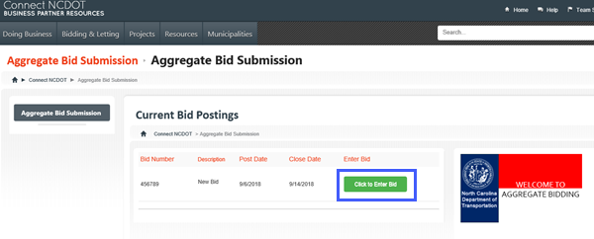

Complete the Aggregate Bids Form

- Fill out all the information requested in the form. Do not save until the attachment has been added.

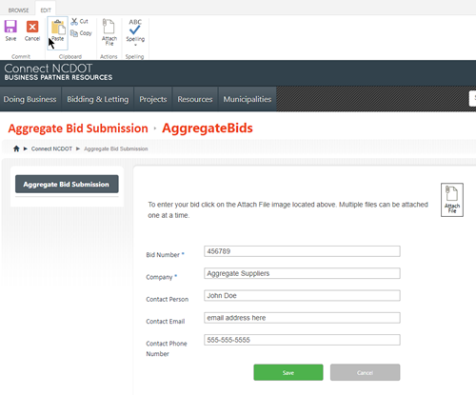

Attach the Bid
- In the form click on Attach File. This will open the attachment page.

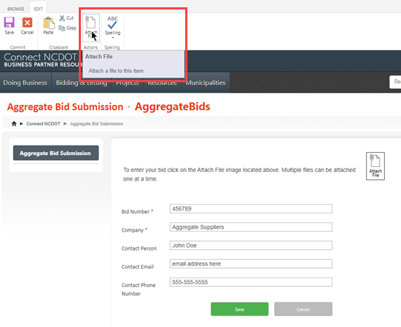

- In the Attachment Page click Choose File this will open your desktop.
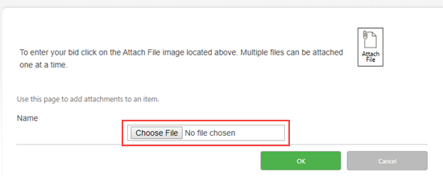

- Navigate to the file you are going to attach. Select the file and click the Open button to add the file.
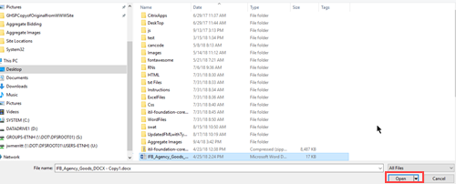
- The file will be added in the Choose File text box. Click OK to complete adding the attachment.
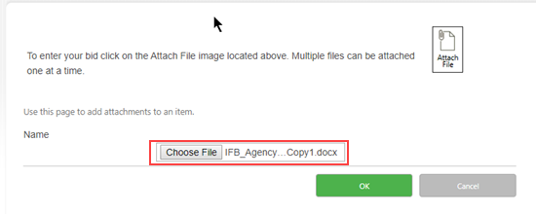

- The bid has now been added as an attachement. Click on Save to Enter the Bid
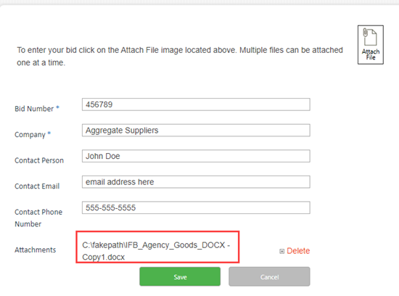
- Once the bid is entered the Thank You page will be shown and you will receive an email confirmation that the bid was received.

